Access to High Performance Computing:
Tier-2 Technical Assessment Form

Instructions:
- Complete Section 1 below as fully as possible. If you have any questions or require clarification, please contact the centre which you would like to apply for resources on. Contact details for each centre can be found in Appendix 1 of the Access to HPC call document.
- Return the completed form (as a Word document) to the centre which you are applying to by using the appropriate contact identified in the bullet point list above along with a short project description.
- The Tier-2 team will complete Section 2 and will contact you directly for more information if it is required. This may take up to 10 days from receipt of the completed form.
- The Tier-2 team will return the fully completed form to you so you can include it in your application.

Notes for Applications:
- Each service may specific restrictions on the form of the applications it accepts. Details on these can be found in Appendix 1 of the Access to HPC call document.
- Applicants should supply quantitative evidence that the codes to be used scale to cpu/gpu/node counts requested. Details on the evidence required can be found in Section 1, Part 6. Please note this section is not mandatory for Tier-2 systems that have novel architectures.

Section 1: HPC Resources and Case for Support
(To be completed by the applicant)

- Project Information.

  - Project Title: LURID2: Further study of URI deployment
  - Tier-2 Centre applying to: Cirrus

  - PI Name and Contact Details.

Name: | Henry S. Thompson
Department: | Informatics
Institution: | University of Edinburgh
Position Held: | Professor of Web Informatics
Address: | 4.22 Informatics Forum; 10 Crichton Street; Edinburgh
Postcode: | EH8 9AB
e-Mail: | ht@inf.ed.ac.uk
Telephone: | +44 7866 471 388
Nationality: | UK

  - Contact details for application (if different from PI above)
N/A
  - Proposed start date of Tier-2 use: 1 November 2022

  - Project length (months) of Tier-2 use: 1 year
  - Brief Project Summary
Longitudinal study of usage patterns of URIs in web pages allows us to detect trends that are important for managing the evolution of Web Architecture. The proposed work will extend our work in the LURID (ec184) project (EPSRC Tier 2, 2021-9 thru 2022-9), using Common Crawl to measure e.g. the shift from http: to https: (which reduces web-cache effectiveness) and the uptake of persistent identifiers (which alleviates link rot). We’ll expand work done on comparison of links found in HTML vs PDF pages, and use our new approach to validating the representativeness of Common Crawl in order to identify and recommend the best 1% segment of recent months’ crawls.
- Previous Use of HPC Resources.

  - Which other HPC services have you used?

Cirrus; Microsoft Azure

- If you have used other HPC services please provide a brief summary of the core/GPU/KNL node hours used (as appropriate) and the types of jobs run (codes, core/GPU/KNL node counts, typical job lengths):

Cirrus: Something like 400K core hours, typical job run 4--10 hours on 2--5 nodes, 36 cores each. Mixture of Hadoop/Nutch web crawler and locally-produced PDF scraper code (shell scripts, Python) using gnu parallel, bash and poppler libraries. Working with multi-TB Common Crawl datasets hosted on /beegfs.
Azure: Several 1000 node hours on 4- and 6-node dedicated clusters, streaming large S3 data-sets through scripts and Python code using either Hadoop, Spark or gnu parallel.

- Tier-2 Software and Support Requirements.
  - Summary of software requirements.

What are the main codes you will be using?
See 3 above. Crawler is based on Nutch, locally patched and built, see /home/dc007/dc007/hst/src/nutch-cc. For sample jobs see e.g. /home/dc007/dc007/hst/bin/cdx.sh and …/bin/bigpdf.sh

Software requirements (e.g. compilers, libraries, tools):
Linux, bash, Python, C, gnu parallel, possibly Hadoop or Spark
Support Requirements
How do you plan to port and optimize your code on Tier-2?
Existing expertise in our group. CSE support not required.

Please summarise any other support requirements for this project:
None
- Proposed Use of Tier-2 Resources.

  - Job size mix for the project
Please see notes at beginning of this document regarding the maximum amounts of time that can be applied for and consult any call guidelines.

 | Largest Job | Typical Job | Smallest Job
Number of nodes | 5 | 2 | 1
Number of cores/GPUs used per node | 36 | 15 | 8
Wallclock time for each job* | 4 days | 5 hours | 1 hour
Number of jobs of this type | ~12 | 100s | ~50
Memory per node required. | Cirrus standard provisions | Cirrus standard provisions | Cirrus standard provisions

*The maximum permitted wallclock time per job is a function of local Tier-2 centre policy.

Amount of compute resource: 500,000 CPU Hours
Notional Cost: [TA person please fill in]

  - Disk space requirements.
You may find it easier to complete this section after completing Section 7 (Data Management and Transfer) below.

 | Storage
Core source files and data sets | 200TB, on /beegfs, inherited from existing Paracrawl (dc007) project
Working storage | Cirrus standard provision
- Usage Breakdown
The total number of units requested above must be broken down into 3 month periods that span the length of access to Tier-2 that has been requested (e.g. if you have requested 1 year of access in total then the units must be split into four 3 month periods). Please add the correct number of rows to the table below for the total length of your project.
If your application is successful then these period allocations may be enforced on the Tier-2 centre in the following way:
- Any unused allocation at the end of a period may be lost
- You may not be able to move units between different allocation periods

Quarter 1 (months 0-3) | 150,000
Quarter 2 (months 3-6) | 125,000
Quarter 3 (months 6-9) | 150,000
Quarter 4 (months 9-12) | 75,000
- Scaling Evidence to Support Proposed Use of Tier-2 Centre
The number of units requested and the job sizes specified in 4.1 above must be backed up by quantitative evidence that the code scales efficiently to the job sizes requested. The evidence must include:
- A graph or table of the speedup for a similar problem using the code on another HPC system. The speedup should be provided relative to the smallest number of cores cores/gpus/nodes that can be used feasibly (see examples below).
The primary tasks are all straight-forward data-parallelism tasks, e.g. link and header extraction from pdf files in 10s of thousands of Common Crawl and/or Internet Archive files, each of which is 1GB zipped. The outputs per input file are typical very small by comparison.

The following graph is taken directly from [1], a MInf thesis completed in 2020 under my supervision. It reports on the scaling of a tool which compiles a simple specification of such tasks wrt Common Crawl into gnu-parallel, tested using Microsoft Azure. Over the last year as part of the LURID project I and MSc students have used this approach on Cirrus with comparable results.

The key point here is that the decompression time swamps the actual task-specific computation time, and we see from the graph that decompression scales linearly with processors up to 36, which is the number of cores on Cirrus nodes.
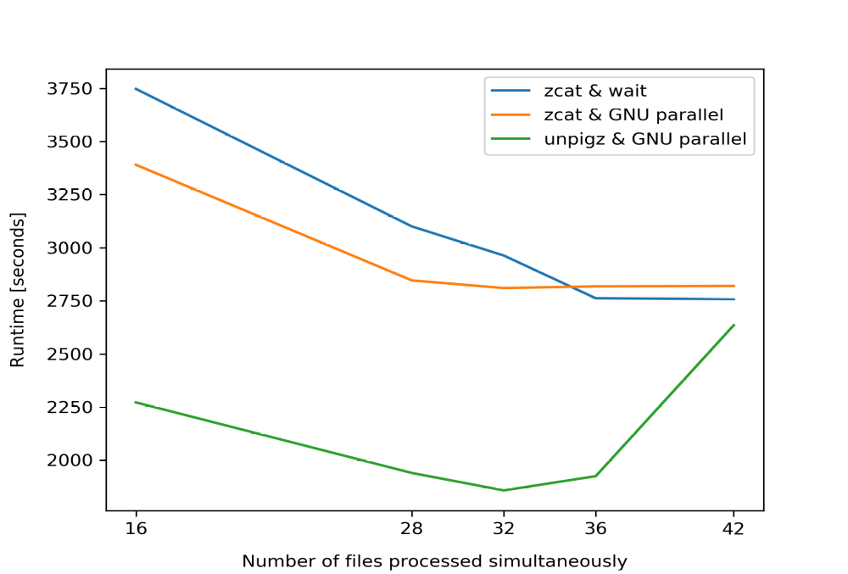
Figure 6.1: Performance comparison of different bash tools. One thousand locally
stored WARC files (approximately 850GB of compressed data) were processed using
each set of tools. Comparison was repeated for different numbers of files processed
simultaneously.

[1] http://www.ltg.ed.ac.uk/~ht/Lukasz_Domanski_MInf_proj.pdf
- Data Management and Transfer
This section asks some basic questions about the data generated on Tier-2 by the proposed calculations.
7.1 How many files are typically produced by each job?
1000s, divided into 100 subdirectories
7.2 How much data is read in by each job?
60—70,000 gzipped files, each around 1GB == 50—60TB
7.3 How much data is produced by each job?
1GB
7.4 What percentage of the produced data do you expect to transfer?
- To the centres storage facility? None
- Off Tier-2? Negligible, in the form of summary tables and statistics
7.5 How do you plan to transfer data from the Tier-2 centre to the (insert storage facility)?
N/A
7.6 How do you plan to transfer data off Tier-2/Storage facility?
ssh for small summary tables

N.b. Applicants are responsible for ensuring copies of all data. The Tier-2 services are not liable for any data loss on the systems.
Section 2: Technical Assessment (To be completed by Tier-2 team).

Date Received by Tier-2 centre: [Enter received date]

Do the applicants have the technical expertise required for the proposed work? | Yes/No

Is the software specified technically suitable for the Tier-2 machine requested? | Yes/No

Is the compute time requested reasonable and has the job breakdown been technically justified? Are the storage requests reasonable? | Yes/No

Has scaling evidence been provide that shows speedup to required job size for the software specified? | Yes/No

Is the data management and transfer plan reasonable and technically sound? | Yes/No

Is the application, as outlined above, suitable for access to the Tier-2 service? Yes / No

Does the project require the technical capabilities of Tier-2?
Would a different computing resource be more appropriate? If so, which one?

Name: [Enter name]
Position: [Enter job title]
Date: [Enter date completed]

